NEPAL COLLEGE OF INFORMATION TECHNOLOGY
Pokhara University
LAB REPORT : Basic Discrete-Time Signals
Course | Data Communication (CMP-335)
Experiment No. | 2
Experiment Title | Basic Discrete-Time Signals
Name | Suraj Kumar Jha
Roll No. | 231537
Program | B.E. Information Technology, 6th Semester

1. Objective
- To understand and generate basic discrete-time signals using MATLAB.
- To plot and visually analyze the unit step, unit impulse, ramp, signum, and exponential (increasing and decreasing) signals.
- To observe the effect of signal parameters on the shape and amplitude of discrete-time signals.

2. Theory
A discrete-time signal is a sequence of numbers defined only at discrete instants of time, usually denoted as x(n), where n is an integer representing the sample index. Unlike continuous-time signals, discrete-time signals are undefined between sample points. These signals form the foundation of digital signal processing and are used to model, analyze, and test the behaviour of discrete-time systems. The basic or elementary discrete-time signals discussed in this experiment are building blocks that can be combined to represent more complex signals.

2.1 Unit Step Signal
The unit step signal, denoted u(n), is defined as:
u(n) = 1, for n ≥ 0 u(n) = 0, for n < 0
It has a constant amplitude of 1 for all non-negative values of n and is zero for negative n. The unit step signal is widely used to test the response of a system to a sudden, sustained input, and is analogous to switching on a constant signal at n = 0.

2.2 Unit Impulse Signal
The unit impulse (or unit sample) signal, denoted δ(n), is defined as:
δ(n) = 1, for n = 0 δ(n) = 0, for n ≠ 0
The unit impulse is the most fundamental discrete-time signal. Every discrete-time signal can be expressed as a weighted sum of time-shifted impulses, which makes the impulse response of a system central to the analysis of linear time-invariant (LTI) systems through convolution.

2.3 Ramp Signal
The unit ramp signal, denoted r(n), is defined as:
r(n) = n, for n ≥ 0 r(n) = 0, for n < 0
The ramp signal increases linearly with n for non-negative indices and is zero elsewhere. It can also be obtained by multiplying the index n with the unit step signal, i.e., r(n) = n·u(n), and is commonly used to study the response of systems to linearly increasing inputs.

2.4 Signum Signal
The signum function, denoted sgn(n), indicates the sign of n and is defined as:
sgn(n) = 1, for n > 0 sgn(n) = 0, for n = 0 sgn(n) = -1, for n < 0
The signum signal is closely related to the unit step signal through the relation sgn(n) = 2u(n) - 1 (with a suitable definition at n = 0), and it is useful for representing polarity or direction in a signal.

2.5 Exponential Signals
A discrete-time exponential signal has the general form x(n) = A·e^(αn), where A is the amplitude and α determines the rate of growth or decay. When α > 0, the signal is an exponentially increasing signal, and its amplitude grows as n increases. When α < 0, the signal is an exponentially decreasing (decaying) signal, and its amplitude reduces towards zero as n increases. Exponential signals are important because they appear naturally in the analysis of physical systems such as charging/discharging circuits, population growth or decay models, and the natural response of linear systems.

3. Apparatus / Software Used
- MATLAB (R2023a or equivalent) with the Signal Processing toolbox functions stem, subplot, and exportgraphics.
- A computer system capable of running MATLAB.

4. Procedure
- Define the discrete time index vector n ranging from -5 to 5.
- Generate the unit step, unit impulse, and ramp signals using logical and arithmetic operations on n.
- Generate the signum signal using MATLAB's built-in sign() function.
- Generate the exponentially increasing and decreasing signals using the exp() function with positive and negative rate constants respectively.
- Plot each signal using the stem() function, which is appropriate for discrete-time (sampled) data, arranging related signals together using subplot().
- Label each plot with an appropriate title, x-axis (Time Index n), and y-axis (Amplitude), and enable the grid for readability.
- Export the resulting figures as high-resolution PNG images using exportgraphics().

5. MATLAB Code
clc;
clear;
close all;

%% ==========================================================
% Signal Generation
%% ==========================================================
n = -5:5;

% Unit Step Signal
unit_step = (n >= 0);

% Unit Impulse Signal
impulse = (n == 0);

% Ramp Signal
ramp = n .* unit_step;

% Signum Signal
sgn_signal = sign(n);

% Exponential Increasing Signal
exp_inc = 4*exp(0.2*n);

% Exponential Decreasing Signal
exp_dec = 4*exp(-0.2*n);

%% ==========================================================
% Figure 1 : Unit Step, Impulse and Ramp
%% ==========================================================
figure;
subplot(3,1,1)
stem(n,unit_step,'filled','LineWidth',1.5)
grid on
xlabel('Time Index (n)')
ylabel('Amplitude')
title('Unit Step Signal')
ylim([-0.5 1.5])

subplot(3,1,2)
stem(n,impulse,'filled','LineWidth',1.5)
grid on
xlabel('Time Index (n)')
ylabel('Amplitude')
title('Unit Impulse Signal')
ylim([-0.5 1.5])

subplot(3,1,3)
stem(n,ramp,'filled','LineWidth',1.5)
grid on
xlabel('Time Index (n)')
ylabel('Amplitude')
title('Ramp Signal')

exportgraphics(gcf,'Figure1_BasicSignals.png','Resolution',300);

%% ==========================================================
% Figure 2 : Signum and Exponential Signals
%% ==========================================================
figure;
subplot(3,1,1)
stem(n,sgn_signal,'filled','LineWidth',1.5)
grid on
xlabel('Time Index (n)')
ylabel('Amplitude')
title('Signum Signal')
ylim([-2 2])

subplot(3,1,2)
stem(n,exp_inc,'filled','LineWidth',1.5)
grid on
xlabel('Time Index (n)')
ylabel('Amplitude')
title('Exponentially Increasing Signal')

subplot(3,1,3)
stem(n,exp_dec,'filled','LineWidth',1.5)
grid on
xlabel('Time Index (n)')
ylabel('Amplitude')
title('Exponentially Decreasing Signal')

exportgraphics(gcf,'Figure2_ExponentialSignals.png','Resolution',300);

%% ==========================================================
% End of Program
%% ==========================================================
disp('--------------------------------------------');
disp('Basic Discrete-Time Signals Plotted');
disp('Figures exported successfully.');
disp('--------------------------------------------');

6. Results
The MATLAB program was executed successfully for the time index n = -5 to 5, and the following discrete-time signals were plotted.
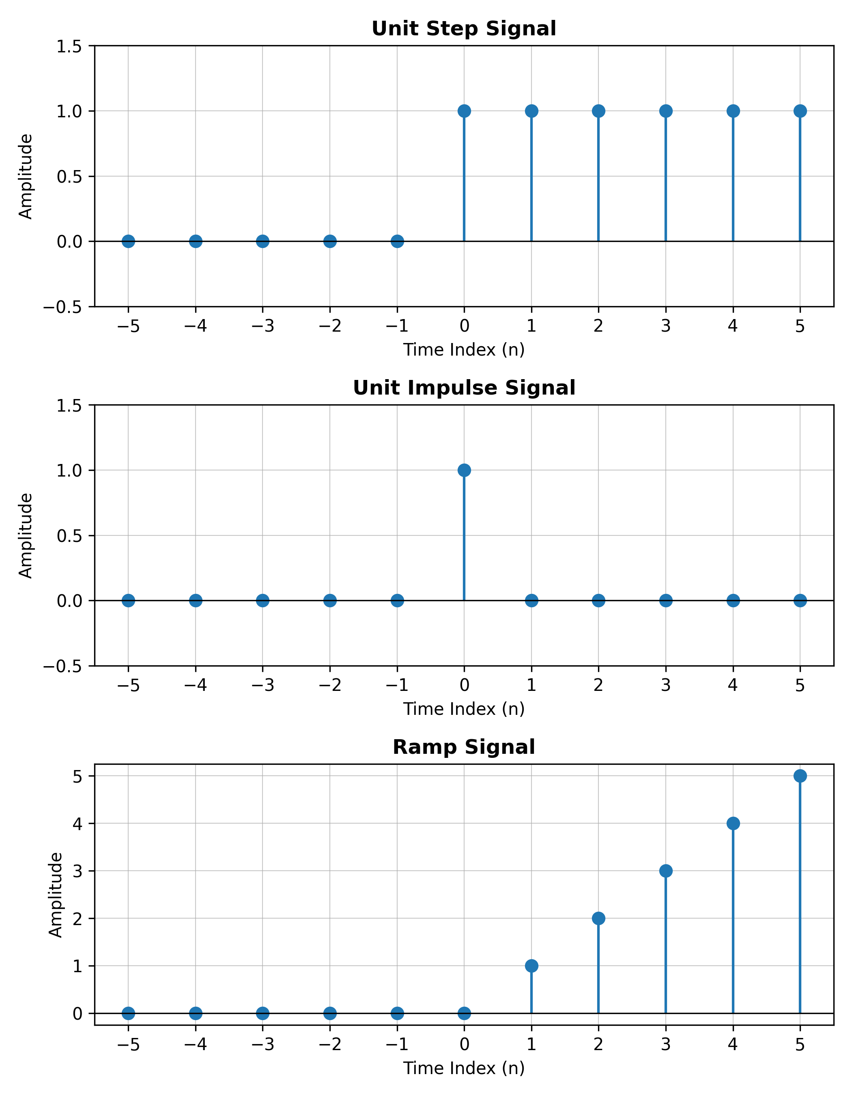
Figure 1: Unit Step, Unit Impulse, and Ramp Signals
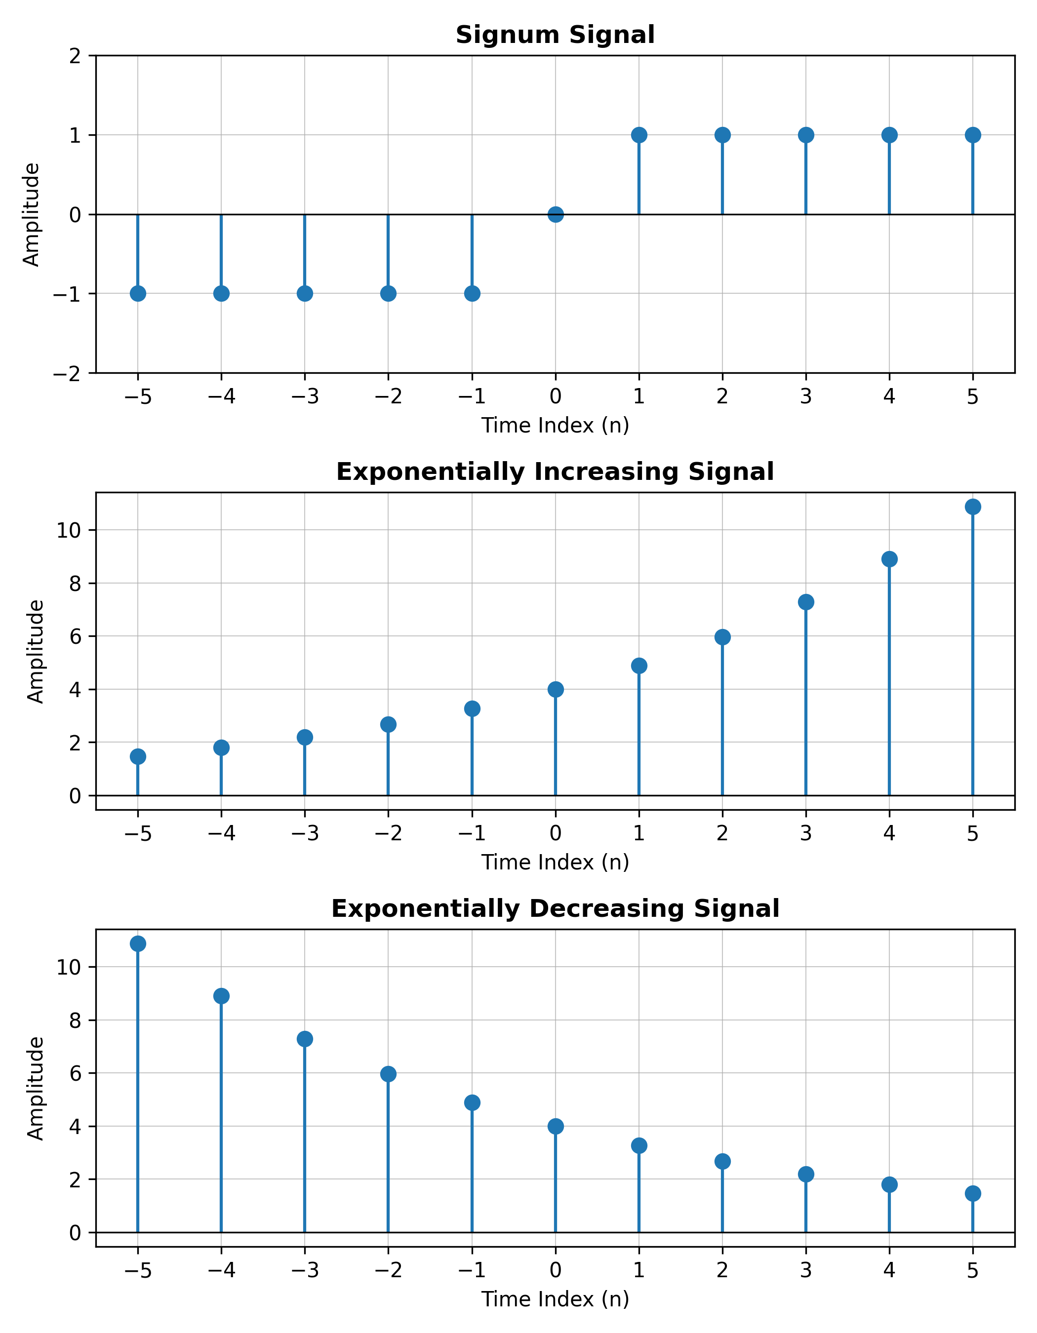
Figure 2: Signum, Exponentially Increasing, and Exponentially Decreasing Signals

7. Discussion
From Figure 1, the unit step signal is observed to be zero for all n < 0 and constant at 1 for n ≥ 0, confirming its role as an on/off switching signal. The unit impulse signal shows a single non-zero sample of amplitude 1 at n = 0, consistent with its definition as an idealized, instantaneous signal. The ramp signal increases linearly for n ≥ 0, exactly matching n·u(n), and remains zero for negative n.
From Figure 2, the signum signal takes the value -1 for n < 0 and +1 for n > 0, clearly showing the sign-detecting behaviour of the function. The exponentially increasing signal (α = 0.2) grows steadily with n, while the exponentially decreasing signal (α = -0.2) decays towards zero as n increases, both starting from the same amplitude of 4 at n = 0. These results confirm the theoretical definitions of each elementary discrete-time signal and demonstrate how the sign of the exponent controls growth versus decay.

8. Conclusion
In this experiment, the basic discrete-time signals — unit step, unit impulse, ramp, signum, and exponential (increasing and decreasing) — were successfully generated and plotted using MATLAB. The plotted waveforms matched the theoretical expectations for each signal type, reinforcing the fundamental concepts of discrete-time signal representation that form the basis for the analysis of discrete-time systems.

